Induction machine exercise

# Introduction

This document contains instructions and assignments for the Induction Machine assignment. You should also use this document as a template for your report. Please state your answers in the textboxes provided and feel free to expand the textboxes as you please. You will have to submit this document on DTU Learn as pdf.

You will have 90 minutes in the laboratory for the experiments, including all preparation. Always consider the range of the measurement equipment and the accuracy of your measurements. Your report will reflect your learning and knowledge. Ensure that you are consistent in your report with significant digits, axis labels, units, etc. as these will affect your overall mark.

**SAFETY IS MOST IMPORTANT!!!!**

**You need to realise that you are operating with high power, rotating components and high voltages. Although the laboratory has been designed to be a safe workspace, your safety is your responsibility. If you are in doubt how to perform the measurements or suspect something might be unsafe, contact senior staff immediately.**

# Identification

Group number: **4**

Group participants (names/ student numbers):

|  |  |  |  |
| --- | --- | --- | --- |
|  | Name | Student number | Percentage of contribution |
| Member 1 | **Andrea Di Lorenzo** | **S237087** |  |
| Member 2 | **Giovanni Maria Francesco La Scala** | **s237081** |  |
| Member 3 |  |  |  |
| Member 4 |  |  |  |

# Experimental Setup

The experiments will be carried out in building 329 (Meeting place is atrium of the building 329a). There are three setups such that three groups can work in parallel. It is compulsory for all group members to attend the experiments. The time slot starts and ends sharp at the designated time in the timetable.

# Setup

The setup bench (fig. 1) has three phase supply (3 x 400V) which is fed through a HFI relay and a fused circuit breaker to a three-phase autotransformer (3 phase adjustable voltage source) **designated as 1** in the figure 1. The autotransformer has a maximal phase voltage of 230V.

The black lines indicate how the wiring in the cabinet is carried out. You are expected to complete the missing connections with extra banana cables, which are available in the lab. The protection element(s) must be part of your experimental circuit.

The voltage from autotransformer needs to be fed to the wattmeter (**indicated by 2** in the figure 1.) and before you connect the supply lines to induction machine which is indicated by number 4 in the figure (a for the diagram and b for the actual machine). Digital wattmeters (DIFFs) will be provided as alternative to ones indicated in Figure 1.

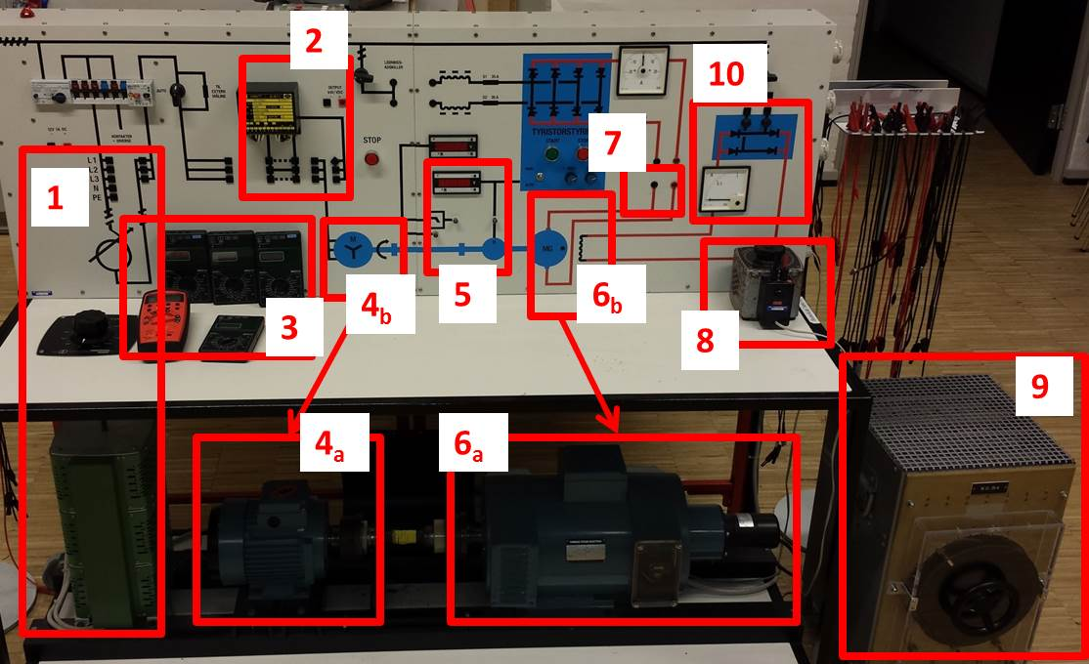

*Fig. 1 Experimental setup without connections*

You will be provided 2 multimeter in total.

Induction machine **(number 4b in the figure1)** and DC machine **(number 6 in the figure1)** are connected by a shaft. Speed of the shaft is measured by tacho-generator and is displayed in RPM. **The speed** is indicated on the front display **marked by number 5 in the figure 1**. In the case digital redout is not working, you will have a BNC connector you can use to measure DC voltage which is proportional to speed (constant is written on the board).

In addition, the value of the **shaft torque** between machines is also measured and displayed on the front display **marked by number 5 in the figure1**.

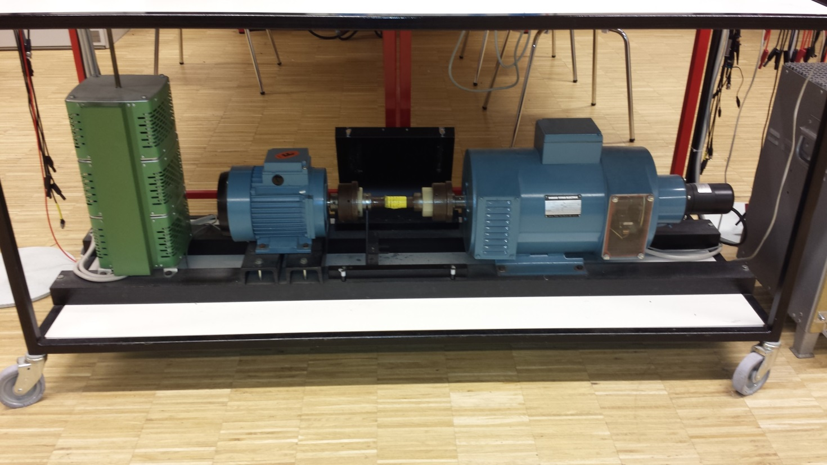

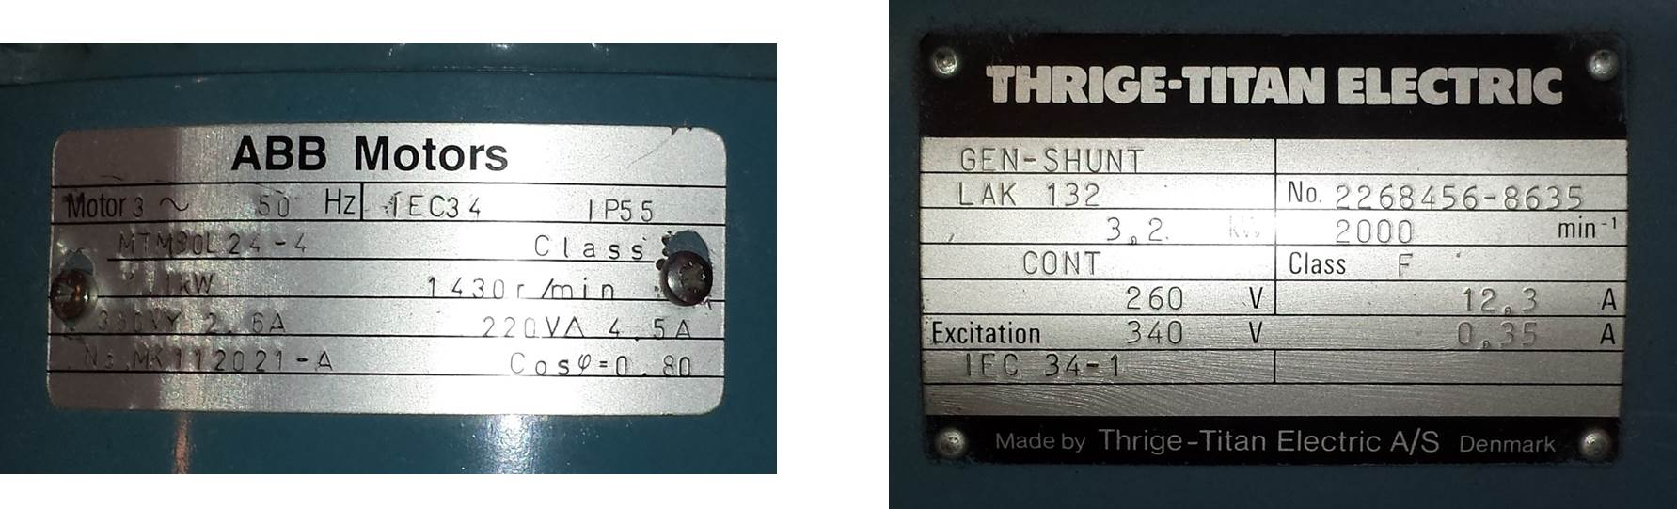Fig. 2 Machine test rig

DC generator is used to load the Induction motor. DE machine is electrically excited by a single phase auto-transformer **(number 8 in figure 1)**. Excitation circuit contains diode rectifier, as shown in circuit diagram and indicated by number 10 in the figure 1. DC machine **armature terminals** are accessible on the front **indicated by number 7 in figure 1**. **Load resistor**, i.e. the shunt, **number 9 in the figure 1**, is available for the experiments.

DC and induction machine name plates are shown in fig.2. As the power of DC machine is approximately two times higher than induction machine, the rated torques will be also mismatched. You are expected to account for this and other hardware limitations due to rated values during your experiments. You always need to be aware the ratings of all devices and use then in safe manner within the ratings.

# Tasks

The groups will have to connect the wiring and the measurement equipment corresponding to the requirements of experiment which is to be performed. Teacher of technician will be there to assist you. YOU MUST ASK FOR STUFF TO CHECK YOUR CONNECTIONS AND POWER UP THE SETUP BEFORE EACH EXPERIMENT!!!

Your task during the Laboratory exercise is to perform the experiments and collect the data for the set of experiments. The questions where you need to collect the data or not the behaviour of the machine are marked with yellow. Remaining questions, marked green, you should make sure you have noted all information to answer them but the answering process should be done **after** the Lab visit.

During your Lab Visit, you will do following experiments (estimate how much each test lasts):

* (5min) Phase resistance measurement for both Induction and DC machine: Sec.1. Here you will need to measure the phase resistance of induction motor using the multimeter.
* (15min) “No Load” test for the Induction Motor: Sec.2.
  + No load test for induction motor consists of supplying the induction motor with controllable 3phase terminal voltage (from Auto-transformer) while shaft is fee to spin. Measurements you should take are terminal voltage, phase current, active and reactive powers and shaft speed. You should start the experiment with nominal voltage and gradually reduce it while noting the measurements. You should end up with 10-15 terminal voltage values.
* (5min) Phase Sequence demo: Sec.4.
* (5min) Loss of Phase demo: Sec.5
* (10min) “Blocked Rotor” test for the Induction Motor: Sec.6
  + Blocked Rotor test for induction motor consists of supplying the induction motor with low controllable 3phase terminal voltage (from Auto-transformer) while shaft is restricted from spinning. Staff will demonstrate how to do achieve this. The terminal voltage is set (usually max10% of nominal value) so phase current in the machine is nominal. Measurements you should take are terminal voltage, phase current, active and reactive powers and shaft torque. You should start the experiment with nominal phase current and gradually reduce it while noting the measurements. You should end up with 5-10 sets of measurements.
* (15min) And the “Load” test for the Induction Motor for 2 terminal voltages: Sec.7
  + To perform Load - test for induction motor, you need to set constant 3phase terminal voltage (from Auto-transformer) and gradually increase the loading on the shaft while noting the measurements. The shaft load is controlled with DC machine, in particular you control the voltage of the field winding for DC machine and with it the load Induction motor sees. Measurements you should take are terminal voltage, phase current, active and reactive powers and shaft torque. You should record up to 5 sets of measurements for two values of terminal voltage, as specified in table.

Questions and Experiments

Q1. What are the power ratings of induction and DC machine? Please collect nameplate info for both machines and describe their meaning.

|  |
| --- |
| For the induction machine (ABB Motor) the power rating is given and is 1.1kW, it can be verified by calculating the power using the rated voltage and current, P = V*I = 220 * 5 = 1100 = 1kW. For the DC machine the power is 3.2 kW, it can be verified using the rated voltage and current, the rated voltage is 260 V and the rated current is 12.3 A, so the power is P = V*I = 260 * 12.3 = 3198 ≈ 3.2kW |

Q2. What is the speed range for both machines provided that they are excited with rated voltage value?

|  |
| --- |
| For the induction machine the rated speed is 1430 r/min (rotation per minute).  For the DC Machine the rated speed is 2000 min-1 (rotation per minute). |

Q3. What is the number of poles of the induction machine: (Include derivation process as well)

|  |
| --- |
| The number of poles in an induction motor can be calculated using the formula: $n_{s}= \frac{120 f}{p}$ where **ns** is the synchronous speed, **f** is the frequency and **p** is the number of poles. Then solving for **p: $$p= \frac{120 f}{n_{s}}= \frac{120*50}{1430}=4.19 p= \frac{120 f}{n_{s}}= \frac{120*50}{1500}=4$$**  So, the induction motor has 4 poles. This is due to the fact that the rated speed should be 1500 r/min. |

Q4. Identify the type of the Induction (and DC machine). Describe where the rotor terminals of induction machine and DC machine are.

|  |
| --- |
| ABB Motors: the type of induction machine is squirrel cage induction motor, which is deduct because there are no rotor terminals accessible from outside.  THRIGE-TITAN Electric: This is a shunt-wound DC generator, indicated by “GEN-SHUNT” on the nameplate. |

Q5.Which machine is motor and which is generator in these tests?

|  |
| --- |
| The ABB Motors nameplate is from an induction motor, instead the THRIGE-TITAN Electric nameplate is from a generator “GEN-SHUNT”. So the Induction machine is the motor and the DC Machine is the generator in these tests. |

# Resistance Measurements

Estimate the average phase resistance of the Induction machine using resistance measurements at the terminals.

|  |  |
| --- | --- |
|  | Induction machine |
| RRS [Ω] | 13.85 Ω |
| RST [Ω] | 13.92 Ω |
| RTR [Ω] | 13.91 Ω |
| Rph_average [Ω] | 13.89 Ω |

RRS is the resistance between phase R and S. RST is the resistance between phase S and T. RTR is the resistance between phase T and R. Rph is the average phase resistance.

Estimate the average winding resistance of the DC machine using resistance measurements at the terminals. Compare precision of obtained results for resistance from multimeter and DC source.

|  |  |
| --- | --- |
|  | DC machine |
| Ra [Ω] | 1.6 Ω |

Q6. How are the stator windings of induction machine connected?

|  |
| --- |
| The stator windings of the induction motor can be typically connected in either star (Y) or delta (Δ) configuration. Based on the nameplate information, the motor has a voltage rating of 380 V for star connection and a voltage rating of 220 for Delta connection. During these experiments the stator windings are star connected. |

Q7. Considering which material is most likely to be used for stator windings in machines, calculate in percentage how much the resistance would change if the winding temperature is increased from 20°C to 100°C during operation.

|  |
| --- |
| The material commonly used for stator windings in motor is copper. The resistance at temperature T (RT) can be calculated form the resistance at 20° C (R20) using the formula: $$R_{T}= R_{20}*\left(1+ α*\left(T-20\right)\right)$$ where $α=0.00393$ is the temperature coefficient of resistance. Using this formula, the percentage increase in resistance when the temperature increases from 20°C to 100°C is calculated as follows: $$\% increase=\frac{R_{100}- R_{20}}{R_{20}}*100 =\frac{R_{20}*\left(1+ 0.00393*\left(100-20\right)\right)-R_{20}}{R_{20}}*100$$ The resistance would increase by approximately 31,44% if the temperature increases from 20°C to 100°C. |

Q8. The resistance measurements are carried out with DC signals. Discuss the validity of using DC measurements for AC analysis machines. Explain the reason why the AC resistance can be different from the DC measured resistance.

|  |
| --- |
| DC resistance measurements can be a good approximation for the AC resistance if the frequency is low enough that skin effect and proximity effect are negligible. However, at higher frequencies, AC resistance can differ from DC resistance due to several factors. Thus for accurate AC analysis, it is necessary to measure the impedance which include both resistance and reactance and not just the resistance. |

# Induction machine “No Load” Test

Record the No Load (NL) characteristic of the induction machine. You should record between 10 and 15 operating points.

|  |  |  |  |  |  |  |  |  |  |  |  |  |  |  |  |
| --- | --- | --- | --- | --- | --- | --- | --- | --- | --- | --- | --- | --- | --- | --- | --- |
| V1 [V] | 408.1 | 384.7 | 368.2 | 349.2 | 332.2 | 315.2 | 301.2 | 283.6 | 265.4 | 225.5 | 206.8 | 187.3 | 146.6 | 109.8 | 69.7 |
| I1 [A] | 1.93 | 1.70 | 1.56 | 1.43 | 1.33 | 1.23 | 1.15 | 1.07 | 0.99 | 0.835 | 0.784 | 0.694 | 0.594 | 0.564 | 0.521 |
| P1 [kW] | 0.266 | 0.241 | 0.208 | 0.184 | 0.170 | 0.171 | 0.149 | 0.138 | 0.128 | 0.111 | 0.104 | 0.100 | 0.086 | 0.079 | 0.076 |
| Q1 [VAr] | 1.354 | 1.150 | 0.973 | 0.840 | 0.748 | 0.665 | 0.578 | 0.507 | 0.435 | 0.296 | 0.247 | 0.196 | 0.118 | 0.064 | 0.047 |
| N  [RPM] | 16.67  * 87.4 | 16.67  * 87.4 | 16.67  * 87.5 | 16.67  * 87.3 | 16.67  * 87.2 | 16.67  * 87.2 | 16.67  * 87.1 | 16.67  * 87.1 | 16.67  * 87.0 | 16.67  * 86.73 | 16.67  * 86.71 | 16.67  * 86.5 | 16.67  * 86.1 | 16.67  * 84.72 | 16.67  * 77.9 |
| T  [NM] | - 0.30 | -0.30 | -0.30 | -0.30 | -0.30 | -0.30 | -0.30 | -0.30 | -0.30 | -0.30 | -0.30 | -0.30 | -0.30 | -0.30 | -0.30 |
| TEST | 210 V | 200 V | 190 V | 180 V | 170 V | 160 V | 150 V | 140 V | 130 V | 110 V | 100 V | 90 V | 70 V | 50 V | 30V |

V1 is the line-to-line voltage at the supply side. I1 is the line current on the supply side. P1 is the three phase power at the supply side and N is the speed of the shaft.

Q9. List the conditions your experiment has been performed at. Discuss briefly the choice/ need for these particular conditions.

|  |
| --- |
| The "No Load" or no-load test for an induction motor has as its primary purpose the determination of the characteristics of the machine in the absence of load. This test for the induction motor consists of providing the induction motor with a controllable three-phase terminal voltage (from the autotransformer) while the shaft is capable of turning.  The measurements taken are the voltage at the terminals, the phase current, the active and reactive powers and the shaft speed, and the instrument that were used are: Multimeter for voltage and current measurements (VMS), a wattmeter to read active and reactive power, Voltage at load side of IM which multiplied by a constant gives a velocity and finally torques readings. |

Q10. Present the No Load characteristic of induction machine:

|  |
| --- |
| Immagine che contiene testo, Diagramma, linea, diagramma  Descrizione generata automaticamente  The figure shows the current vs voltage plot.  This behavior is what we expected, in fact in No Load induction machines the absorbed current is mainly used to overcome losses in the iron (hysteresis and eddy currents) and for the magnetization of the motor core. |

Q11. Is the characteristic linear or non-linear? Explain why this is so.

|  |
| --- |
| The characteristic shown in the graph is nonlinear. This nonlinearity is primarly due to two factors:   1. **Iron Losses**: At lower voltages, iron losses, which include hysteresis and eddy current losses, are proportionally lower. These losses increase with the square of the applied voltage, meaning that at higher voltages, iron losses become more significant and cause a more pronounced increase in current. 2. **Core Saturation**: As the voltage increases, the motor’s core may approach magnetic saturation. When the core is saturated, small increases in voltage can cause large increases in magnetizing current, leading to a nonlinear relationship between voltage and current.   Therefore, the nonlinearity is attributed to the magnetic behavior if the core material and the iron losses, which do not increase linearly with voltage. |

Q12. How does power loss change during experiments? Explain why this is so. Present results also in a figure form.

|  |
| --- |
| The plot showing active power versus voltage, in No Load condition.  As we can see, as the voltage increases, the active power consumed by the motor also increases in a nonlinear manner.  At No Load, input power is equal to the core loss, stator loss, and friction and windage loss.  So it can be explained as follows:   * **At Low Voltages**: The power consumed is primarly due to mechanical losses (like friction and windage) and a small part due to core losses. Mechanical losses don’t vary much with voltage, as they are more related to the physical movement of the shaft, which remains constant at no-load. * **At Higher Voltages**: Core losses start to become more significant. These include hysteresis losses, which occur due to the lag in magnetization of the core material as the magnetic field changes, and eddy current losses, which are produced by induced currents within the core material. Both of these losses increase non-linearly with voltage, with eddy current losses increasing with the square of the voltage. * **Core Saturation**: As the voltage reaches higher values, the core of the motor may approach saturation. At this point, small increases in voltage can cause disproportionately larger increases in magnetizing current, which leads to a steep increase in core losses.   The curve’s chape indicates that the relationship between voltage and power loss is quadratic, which is characteristic of core losses in magnetic materials. These losses are more pronounced at higher voltages due to increased flux density in the core, leading to more significant hysteresis and eddy current losses. |

Q13. What is the efficiency of induction machine in this experiment? Explain why this is so.

|  |
| --- |
| Efficiency in any machine, is calculated as the ratio of the output power to the input power: $$η= \frac{P_{out}}{P_{in}}*100$$ Of course, during this No Load test, the Induction Machine is still consumes power from the electrical supply, that is used to overcome the internal losses due to core losses, windage losses, copper losses. But since the machine operates without any mechanical load, it doesn’t perform any external work. Therefore the output mechanical power is effectively zero. $$η= \frac{P_{out}}{P_{in}}*100=0\%$$ This show that the machine uses this power just to maintain the operation of the motor and overcome inherent losses, without contributing to any productive output. |

Q14. Is the rotor speed constant throughout experiments and is that important?

|  |
| --- |
| In a No Load test for an induction motor, the rotor speed typically remains fairly constant and close to the synchronous speed, which is determined by the supplied frequency and the number of poles in the motor. The synchronous speed is given by the formula: $$N_{sync}= \frac{120 f}{n_{p}}= \frac{120*50}{4}=1500 rpm$$ From the test we get around 1456 rpm and since there is no load that significantly affects the seep of the rotor, it will run only slightly below the synchronous speed, with the small difference being due to the no load losses experienced by the motor. |

Q15. How does the reactive power supply from auto transformer change throughout experiments?

|  |
| --- |
| Immagine che contiene testo, Diagramma, linea, diagramma  Descrizione generata automaticamente  The plot showing reactive power versus voltage, in No Load condition.  As we can see, as the voltage increases, the reactive power increases in a nonlinear way and becomes more pronounced as the voltage approaches higher values.  At No Load, input power is equal to the core loss, stator loss, and friction and windage loss.  The reactive power supplied from the auto-transformer changes throughout the experiment as follows:   * **At Lower Voltages**: the reactive power demand of the motor is relatively low. As the voltage increases, the reactive power increases almost linearly. This is because the inductive reactance of the motor, which dictates reactive power consumption, remains fairly constant at lower levels of flux in the core. * **At Higher Voltages**: As the voltage continues to increase, the reactive power begins more sharply. This sharper rise can be attribuited to the increased magnetizing current required to maintain the magnetic field in the motor’s core. As the core material moves closer to magnatic saturation, small increases in voltage results in a larger increases in magnetizing current, and thus more reactive power is drawn. * **Core Saturation**: The curve’s steepening slope at high voltae suggests that the core is nearing saturation. In the saturation region, the permeability of the core material decreases, requiring more magnetizing current to achieve the same level of magnetic flux, thus leading to a significant increase in reactive power . |

# Induction machine “phase sequence” Test

**Call a senior staff to help you with shaft cover.**

Induction machine is in No-load. Apply low three phase voltage to the stator windings (high enough so the shaft starts to rotate). Mark down the direction of rotation. Change the sequence of the supply phases and repeat the previous step. Mark down the direction of rotation.

|  |  |
| --- | --- |
| Initial Phase sequence | R- S- T |
| Rotation direction | Counterclockwise |
| New Phase sequence | R- T- S |
| Rotation direction | Clockwise |

Q16. Is there a difference between two cases? Explain and argue why this is so.

|  |
| --- |
| Yes, there is a difference between the two cases, and the change in the direction of rotation is expected and intentional. In a three-phase AC induction motor, the direction of rotation is determined by the sequence in which the phase are supplied to the motor’s stator windings. This sequence creates a rotating magnetic field which the rotor follows, thus determining the direction of the motor’s rotation.  When the phase sequence is **R-S-T** the rotation magnetic field moves in a direction that makes the rotor turn **counterclockwise**. Instead changing the sequence in **R-T-S** the rotation magnetic field reverse the direction so this cause the rotor to move in the opposite direction, **clockwise**.  This behaviour is consistent with the right-hand rule of electromagnetism, where point the thumb off right hand in the direction of the magnetic field (from R to S to T) the fingers curl in the direction of current flow. By reversing the sequence, also the magnetic field’s direction reverse and consequently the direction of the rotor’s rotation. |

# Induction machine “loss of phase” Test

Induction machine is in No-load. Apply low three phase voltage to the stator windings. Voltage should be lower than rated but high enough to allow rotor to reach the no load or “idle” speed. Pull out one of the supply lines at induction machine terminals. Observe the machine operation.

|  |  |  |
| --- | --- | --- |
|  | Starting the IM with one phase disconnected | Disconnecting one phase after IM has reached no load speed |
| Observations | It doesn’t work | It works, but the noise increment |

Q17. What have you observed? How will three phase induction machine operate when one phase is lost?

|  |
| --- |
| When starting an induction motor (IM) with one phase disconnected, it doesn’t work as expected because and induction motor requires a rotating magnetic field to start. The rotating magnetic field is produced by the correct sequence and distribution of a three-phase power supply.   However, if you disconnect a phase after the IM has already reached no-load speed, the motor continue to run, but with reduced performance. This is because, once rotating, the inertia of the rotor keeps it rotating even with single-phase power. In this condition, the current in the remaining phases increases to compensate for the loss of the third phase, leading to unbalanced currents and possible damage over time. The motor run with increased vibrations because of the uneven magnetic pull on the rotor. It is not an efficient way to operate a motor as it leads to unbalanced phase currents, higher losses, reduced torque and potential thermal overload. |

Q18. Describe previous experiment in terms of first principles and basics of machine operation. Explain your observation for experiment using same first principles.

|  |
| --- |
| The operation of an induction motor relies on a rotating magnetic field produced by three-phase currents. This field induces a current in the rotor, which then follows the rotating field, producing torque due to the interaction of magnetic fields.   Starting with one phase disconnected: Without all three phases, the symmetrical rotating magnetic field is not established, thus no starting torque is generated, and the motor cannot start.  Disconnecting one phase after no-load speed reaches: Once the motor is running, the rotor has inertia, and it continues to rotate due to its momentum. The remaining stator phase still produce a rotating field, even if a weaker and unbalanced one, which the rotor can follow due to its existing motion. |

Q19. How will the induction machine operate if the rotor is at stand still and the voltage is supplied only to two phases (one is lost).

|  |
| --- |
| The motor will have difficult starting because it will lack a proper rotating magnetic field. I f the motor starts at all, it will likely be due to asymmetrical starting conditions, and it will draw a significantly current from the two powered phases. The motor will run with excessive noise, vibration, and heat generation. |

Q20. Explain why.

|  |
| --- |
| An induction motor starts and runs effectively due to the rotating magnetic field produced by a balanced three-phase voltage supply. The absence of one phase disrupt this balance.  Lack or rotating field: two-phase supply cannot create a proper rotating magnetic field, which is essential for the motor to start.   Single-Phasing: when the rotor is stationary, and one phase is missing, thee motor behaves similarly to a single-phase induction motor, which inherently does not have a starting torque unless it is equipped with auxiliary means to start.   Asymmetrical conditions: any movement of the rotor under two-phase conditions would be due to unsymmetrical conditions that might produce enough torque to overcome static friction, but this is generally not reliable and highly inefficient. |

# Induction machine - Locked Rotor Test

**Call a senior staff to help you physically lock the rotor.**

Record the blocked rotor (BR) characteristic of the induction machine up to a line current of 5A with all devices included. You should record between 5 and 10 points. Take extra care to perform measurements above machine’s rated current quickly (5 sec max).

|  |  |  |  |  |  |  |  |
| --- | --- | --- | --- | --- | --- | --- | --- |
| V1 [V] | 140.9 | 124.3 | 105.9 | 97.0 | 86.2 | 79.5 | 69.45 |
| I1 [A] | 3.47 | 2.99 | 2.49 | 2.24 | 1.99 | 1.82 | 1.57 |
| P1 [kW] | 0.46 | 0.38 | 0.26 | 0.23 | 0.17 | 0.15 | 0.12 |
| Q1 [kVAr] | 0.64 | 0.49 | 0.34 | 0.29 | 0.24 | 0.19 | 0.15 |
| T [NM] | -1.22 | -0.93 | -0.66 | -0.54 | -0.42 | -0.35 | -0.27 |
| TEST | 70 V | 60 V | 50 V | 45 V | 40 V | 35 V | 30 V |

V1 is the line-to-line voltage at the supply side. I1 is the line current on the supply side. P1 is the three phase power at the supply side.

Q21. Plot the BLR characteristic for the induction machine

|  |
| --- |
| Immagine che contiene testo, linea, Diagramma, diagramma  Descrizione generata automaticamente  The plot shows the Blocked Rotor Test of an induction motor, where the current draw is plotted against the applied voltage.  The BLR test is used to determine:  The maximum starting current that the motor draws when you try to start it with the rotor locked.  The maximum starting torque that the machine is capable of developing under locked rotor starting conditions and the resistance and reactance of the equivalent circuit of the induction machine. |

Q22. Is the characteristic linear or non-linear? Explain why this is so.

|  |
| --- |
| The characteristic is linear as indicated by the almost straight lines correlating current and voltage.  The linear characteristic occurs because, with the rotor locked, the motor behaves similarly to a transformer with its secondary (the rotor) short-circuited. The following reasons explain the linear nature of the characteristic:   * **Ohm’s Law**: the linear relationship between voltage and current reflects Ohm’s Law, as: $$V=R I$$  where R represents the combined resistance of the stator and rotor circuits.   * **Constant Impedence**: unlike normal operation where the rotor’s inductances varies with the flux and rotor speed, in a locked rotor test, the impedence remains constant because the rotor is stationary, and the flux does not change over time. * **Absence of Saturation**: at these low voltage, the motor’s core is unlike to reach saturation point, hence, there are no non-linear effects due to the core’s magnetic saturation. |

Q23. How does power loss change during experiments? Explain why this is so. Present results also in a figure form.

|  |
| --- |
| Immagine che contiene testo, linea, Diagramma, diagramma  Descrizione generata automaticamente  The plot indicates that the active power consumed by the induction motor during the locked rotor test increases with the applied voltage. The relationship is nonlinear, showing that as the voltage increases, the power consumed rises at a growing rate.  This increase in power loss is due to the Joule heating effect, where power loss is proportional to the square of the current .  During the locked rotor condition, the rotor is not allowed to rotate, and the current drawn by the motor is significantly higher than in normal operation. This high current through the resistive components of the motor (stator and rotor windings) results in increased power loss due to resistive heating. Due to the higher magnetic flux density in the iron core brought on by the low voltage and high rotor current, core losses also rise. |

# Induction machine under load - Test

Use the DC machine, connected to a shunt with variable resistance, to load the induction machine and perform the following experiments:

1. Stator voltage of the induction machine is at rated value and is constant during the experiment. Vary the braking torque on the shaft by changing the excitation of the DC machine.

Note: Shunt resistance should be at highest impedance setting

1. Repeat previous experiment with 85% of the rated supply voltage for induction machine.

Record induction machine quantities for approximately 6 values of DC machine excitation, adjusting the induction machine power to range from rated power down to a no load.

|  |  |  |  |  |  |  |  |  |  |  |  |  |  |
| --- | --- | --- | --- | --- | --- | --- | --- | --- | --- | --- | --- | --- | --- |
|  | V1=100% Vrated | | | | | |  | V1=85% Vrated | | | | | |
| V1 [V] | 415.7 | 415.3 | 412.9 | 414.9 | 414.5 | 414.5 | 359.8 | 359.9 | 359.1 | 358.1 | 357.5 | 356.2 |
| I1 [A] | 2.01 | 2.13 | 2.32 | 2.61 | 2.75 | 2.91 | 1.49 | 1.55 | 1.62 | 1.86 | 2.42 | 2.92 |
| P1 [W] | 0.29 | 0.64 | 0.94 | 1.26 | 1.37 | 1.56 | 0.24 | 0.41 | 0.50 | 0.73 | 1.18 | 1.42 |
| Q1 [W] | 1.37 | 1.37 | 1.35 | 1.35 | 1.35 | 1.42 | 0.92 | 0.88 | 0.88 | 0.86 | 0.94 | 1.01 |
| N[RPM] | 16.67  *  88.2 | 16.67  *  86.9 | 16.67  *  85.8 | 16.67  *  84.5 | 16.67  *  83.9 | 16.67  *  83.6 | 16.67  *  87.4 | 16.67  *  86.7 | 16.67  *  86.2 | 16.67  *  85.2 | 16.67  *  83.2 | 16.67  *  81.6 |
| T[Nm] | 0.46 | 2.83 | 4.54 | 6.42 | 7.02 | 8.05 | 0.46 | 1.58 | 2.14 | 3.59 | 6.08 | 7.42 |
| Va [V] | 0 | 60 | 80 | 90 | 100 | 120 | 0 | 40 | 50 | 70 | 100 | 110 |
| Ia [A] | 0 | 0.08 | 0.12 | 0.12 | 0.13 | 0.16 | 0 | 0.06 | 0.07 | 0.09 | 0.11 | 0.14 |
| Vf [V] | 18.4 | 71.7 | 92.5 | 110.4 | 115.5 | 123.8 | 18.3 | 51.2 | 61.3 | 81.3 | 106.7 | 117.4 |

Q24. Calculate the efficiency, torque and reactive power of induction machine for same noted operation points captured in the experiment.

|  |
| --- |
|  |

Q25. How the supply voltage affects the induction machine operation?

|  |
| --- |
|  |

Application

Estimate the equivalent circuit parameters of the test IM at rated conditions.

|  |  |  |  |  |  |
| --- | --- | --- | --- | --- | --- |
| R1 [Ω] | X1 [Ω] | RC [Ω] | Xm [Ω] | R’2 [Ω] | X’2 [Ω] |
| 11.4 | 11.9 | 482.6 | 157.2 | 14.7 | 11.9 |

R1 is the stator phase resistance. X1 is the stator phase leakage reactance. RC is the core loss resistance. Xm is the magnetising reactance. R’2 is the rotor resistance referred to the stator. X’2 is the stator phase leakage reactance referred to the stator side.

Q26. Plot the torque vs speed characteristic of the induction based on derived parameters and for speed range 25%-175% of synchronous speed. Include also experimental results from “Performance under load”.

|  |
| --- |
|  |

Q32. Derive and calculate the maximum electromagnetic torque and corresponding slip.

|  |
| --- |
| $$T_{max}= \frac{poles}{2⋅2πf_{e}}⋅\frac{0.5⋅n_{ph}⋅{V_{1,eq}}^{2}}{R_{1,eq}+\sqrt{{R_{1,eq}}^{2}+{\left(X_{1,eq}+X_{2}\right)}^{2}}} s_{maxT}= \frac{{R_{2}}^{'}}{\sqrt{{R_{1,eq}}^{2}+{(X_{1,eq}+{X_{2}}^{'})}^{2}}}$$ We already know all the parameters involved in the formula; we just need to express the Thevenin’s equivalent circuit quantities:   * A graph with a red dotted line    Description automatically generatedWe extract $R_{1,eq}$ from the real part of $Z_{1,eq}$, which is given by: $Z_{1,eq}= \frac{jX_{m}\left(R_{1}+jX_{1}\right)}{R_{1}+j\left(X_{m}+X_{2}\right)}≃(3.745 + i10.092⋅{10}^{4})Ω⇒R_{1,eq}≃ 3.745 Ω$* We calculate the value for $V_{1,eq}$ as: $V_{1,eq}=V_{1}\frac{jX_{m}}{R_{1}+j(X_{m}+X_{1})}≃\left(1.7714⋅{10}^{2} + i15.68\right)V$  Substituting all the values in the equation we have: $$T_{max}≃ 11.5496 Nm$$ At the maximum torque, the maximum corresponding slip will be: $$s_{maxT}≃0.91$$ |

Q27. Is the magnetization inductance of induction machine, Xm , constant or will it vary with stator current? Why? Support you answer with the plot.

|  |
| --- |
| A graph with a line drawn on it  Description automatically generated  As shown by the plot besides, the magnetization inductance $X_{m}$ seems to be decreasing linearly as the current increases.  Since the flux increases up until it reaches the saturation point of the material the permeability of the material dops making the reactance decreasing accordingly $$L= \frac{NΦ}{I}$$ |

Q28. Is the leakage inductance of induction machine, X1 + X2, constant or will it vary with stator current? Why? Support you answer with the plot.

|  |
| --- |
| For what concerns the leakage inductance of the IM, as the current increases, $X_{1}+X_{2}$ does not change significantly.  For this plot the data from the locked rotor test have been used, which allow us to evaluate: $$X_{1}+{X_{2}}^{'}={\frac{V_{1,locked}}{Q_{1,locked}}}^{2}$$ We are considering here the reactance of the wires, which are made of a linear material (in terms of magnetic circuits). We know that for those material the flux will be a constant and therefore the reactance is a constant as shown by the plot. |

Q29 . Assuming the geometry of induction machine has stayed the same and the aluminium rotor bars have been replaced by a cupper bars, discuss implications this would have on the output power, efficiency, torque – speed characteristic and finally the cost per unit of torque of the machine. Illustrate the “new” torque – speed characteristic in the figure.

|  |
| --- |
|  |

Discussion

Feel free to discuss the laboratory exercise in more details in this section.

|  |
| --- |
|  |